Using git and github with RStudio
1/12/2016
Updated 1/14/2016
Should have done under GIT!

Had setup github account previously
Had downloaded git on work desktop (actually GUI version) previously
See Setting up Git at https://help.github.com/articles/set-up-git/
Need to have RTools on the machine too. find_rtools() may (I didn't) need to be run from command line too.

Two important URLs
[1] http://www.r-bloggers.com/create-r-package-rstudio-github-devtools/
[2] https://support.rstudio.com/hc/en-us/articles/200532077?version=0.98.1103&mode=desktop

First three steps in [1] are correct.

Then go to Getting Started block in [2]. git.exe is in weird place, possibly because I'm using GUI. I did not use SSH RSA Key:
Mine was at C:\Users\teb\AppData\Local\GitHub\PortableGit_LETTERS&NUMBERS\cmd\git.exe (of course!)

Then go to Directions for Git (local) under Adding version control to an existing project block in [2].
Tools|Version Control|Project Setup...

Open Tools|Shell as shown in [2].

Execute these lines from [1] in shell.
git add *
git commit -m "first commit"
git remote add origin git@github.com:username/rpackage.git
git push -u origin master
They evidently setup connection to github for the project. Second line isn't necessary if had committed from within RStudio already. For the third line username is tomeburk for me.
Actually second line isn't recognized!
Looks like the remote add origin just sticks that in Project Setup dialog

Actually the lines provided on the GitHub site that are like those in [1] should be used
Also seems needed to login with GitHub GUI to allow connection to work

Will then be able to Push subsequent commits from within RStudio.

Notes:
Can't work with project in GitHub GUI app???
DID WORK SECOND TIME - it just recognized what I had done!!
I created/edited/saved .R and DESCRIPTION files in RStudio script window.
I ran Build|Check Package
Seems like it's not customary to include "installed version" (i.e. library) in github

Here's what RStudio looked like. Notice version control icon (last icon) in tool bar.

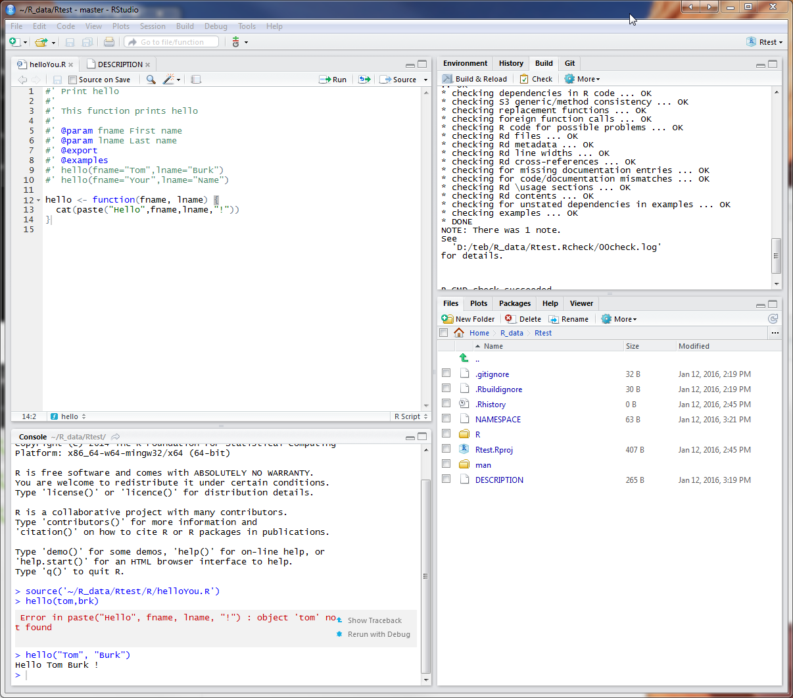

Here's project directory.

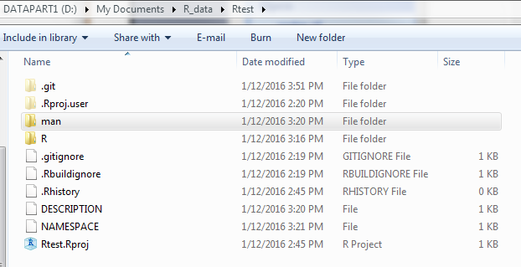

Here's the shell opened from RStudio (Tools|Shell...).

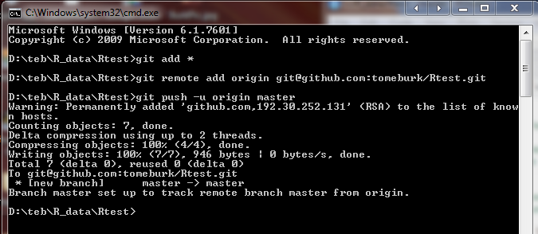

Here's Review Changes (after first commit).

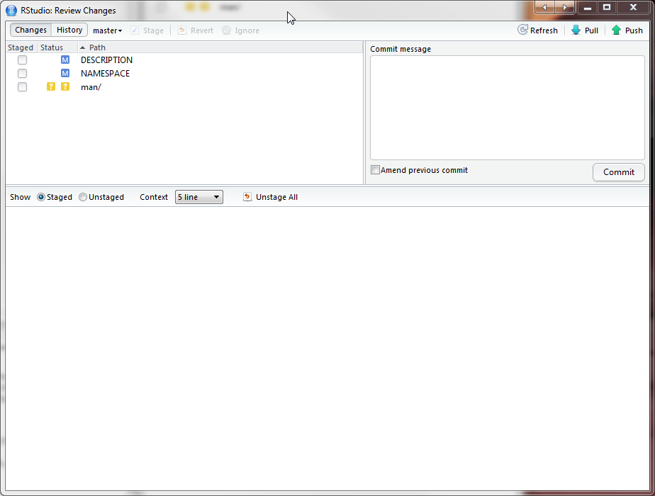

Here's the github repository after last commit and push.

